**Introduction**

PHP is a recursive acronym for "PHP: Hypertext Preprocessor".

PHP is a server side scripting language that is embedded in HTML. It is used to manage dynamic content, databases, session tracking etc.,

**Characteristics of PHP**

* Simplicity
* Efficiency
* Security
* Flexibility
* Familiarity

**PHP Script Tag Types**

* <?php PHP Code ?> 🡪 Canonical PHP Tag
* <? PHP Code ?> 🡪 Short-Open (SGML- Style)
* <script language=”php”>PHP Code</script> 🡪 HTML Script Tag

**Component Needed for PHP Code Running**

* Web server
* Data Base
* PHP Parser

**Commenting PHP Code**

// 🡪 Single Line Comment

/* */ 🡪 Multi-Line Comment

**Note:**

PHP is a Case Sensitive

Statements are Expressions are terminated By a Semi Colon

A Statement in PHP is any expression that is followed by semicolon.

Expressions are Combination of Tokens

Smallest Building blocks are called as token(while, if, $, $val,..etc.,)

**Variables:**

The main way for storing data in the middle of the PHP program is by using the Variable.

**Key Points:**

1. All Variables in PHP are denoted with a leading Dollar Sign ($).
2. Variables are need not to be declared before assigning a value.
3. PHP has 8 Data Types
   * + Integer 🡪 These are numbers without decimal point
     + Double 🡪 Floating point numbers
     + Booleans 🡪 True / False
     + NULL 🡪 it is a special and has only one Value NULL
     + Strings 🡪 Sequence of characters
     + Arrays 🡪 Named and indexed collection of other values
     + Objects 🡪 Instances of class

**Scope of Variables**

1. Local
2. Global
3. Static
4. Function Parameters

**Local Variable:**

A Variable declared in a function and is can be referenced only in that function.

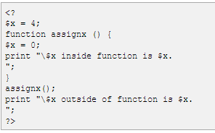

**Out Put:**



**Global Variables:**

A Global variable can be accessed in any part of the program. However in order to modify a global variable it must be explicitly declared to be global in the function in which it is to be modified. This is accomplished by using a key work GLOBAL in front of the variable that should be recognized as global

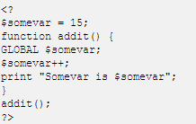

**Static Variables:**

**A** variable which is declared with STATIC key word is called as static variable. Its value remains same in entire the program.

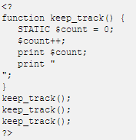

**Function Parameters**

Function Parameters are declared after the function and inside parenthesis.

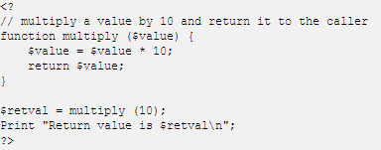

Out Put:

